**Homoscedasticity and Heteroscedasticity**

**Homoscedasticity:**

**Definition:** Homoscedasticity refers to the condition in which the variance of the residuals (errors) in a regression model is constant across all levels of the independent variable(s). In other words, the spread of the residuals is uniform regardless of the value of the predictor variables.

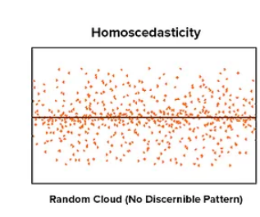

**Principle:**

* **Uniform Variability:** Residuals should exhibit consistent variance across different values of the independent variables.
* **Assumption in Linear Regression:** Many statistical methods, including Ordinary Least Squares (OLS) regression, assume homoscedasticity for the residuals to ensure that the model's inferences are valid.

**Basic Concept:**

* **Visual Check:** Residuals vs. Fitted Values plot. In a homoscedastic situation, residuals should be randomly scattered around zero.
* **Statistical Tests:** Tests such as Breusch-Pagan or White’s test can statistically assess homoscedasticity.

**Advantages:**

1. **Valid Inferences:** Ensures that the standard errors of coefficients are unbiased and reliable.
2. **Efficient Estimators:** OLS estimators are BLUE (Best Linear Unbiased Estimators) when homoscedasticity is present.
3. **Simpler Models:** Assumptions are straightforward, simplifying model interpretation.

**Disadvantages:**

1. **Violation Effects:** If violated, OLS estimates remain unbiased but are inefficient, leading to incorrect standard errors and invalid statistical tests.
2. **Requires Correction:** Detection and correction of heteroscedasticity may be needed, complicating the modeling process.
3. **Model Assumptions:** Over-reliance on the assumption of homoscedasticity can lead to issues if the true data generating process violates it.

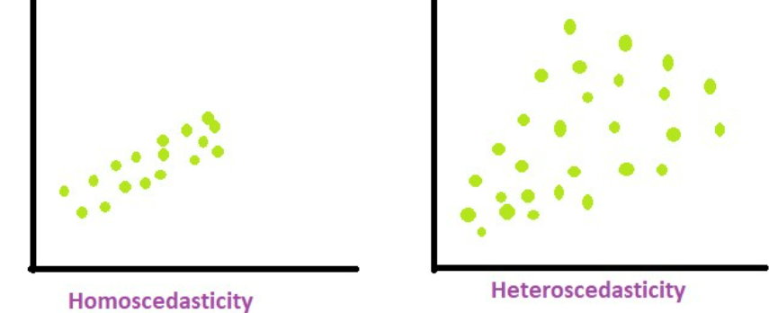

**Heteroscedasticity**

**Definition:** Heteroscedasticity occurs when the variance of the residuals (errors) in a regression model is not constant across all levels of the independent variable(s). Instead, the spread of the residuals varies systematically with the level of the predictor variables.

**Principle:**

* **Variable Variability:** Residuals exhibit changing variance, potentially increasing or decreasing with the level of the predictor variables.
* **Impact on Inference:** Heteroscedasticity can affect the efficiency and validity of regression estimates and inferences.

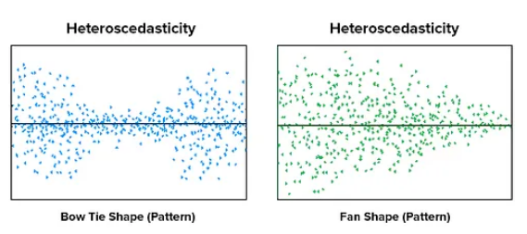

**Basic Concept:**

* **Visual Check:** Residuals vs. Fitted Values plot. In a heteroscedastic situation, residuals might show patterns such as fanning out or contracting as the predictor values change.
* **Statistical Tests:** Breusch-Pagan test, White test, or Goldfeld-Quandt test can be used to detect heteroscedasticity.

**Advantages:**

1. **Model Adaptation:** Detecting heteroscedasticity leads to the application of robust methods or transformations that can improve model reliability.
2. **Enhanced Diagnostics:** Identifying and addressing heteroscedasticity can lead to a deeper understanding of the data and model fit.

**Disadvantages:**

1. **Complexity:** Models and corrections become more complex, such as using robust standard errors or weighted least squares.
2. **Efficiency Loss:** Standard OLS estimates become inefficient, and the validity of hypothesis tests is compromised if heteroscedasticity is not addressed.
3. **Detection Difficulty:** Heteroscedasticity can be challenging to detect and diagnose, especially in large or complex datasets.

In Short Homoscedasticity is the desirable state where residuals have constant variance, ensuring reliable inferences and efficient estimators. Heteroscedasticity is the situation where residual variance changes with predictor variables, leading to inefficiencies and potentially invalid inferences. Both concepts are crucial in regression analysis, with homoscedasticity supporting model validity and heteroscedasticity highlighting the need for more sophisticated approaches or adjustments.